**Extensions to the DIGGS XML Transfer Standard for Processed Geophysical Data**

Report submitted to the Geo-Industry Geophysics Users Group

by

# **Daniel Ponti**, USGS Retired, Redwood City, CA, USA, pontifamily@gmail.com,

**Caleb Kaminski**, Michigan Tech University, Houghton, MI, USA, cjkamins@mtu.edu,

**Derrick Dasenbrock**, FHWA, Washington, DC. USA, derrick.dasenbrock@dot.gov, and

**The GI Geophysics/DIGGS Task Group**

Abstract

The ASCE GI Technical Coordination Council approved a Special Project to expand the DIGGS XML schema standard to accommodate the transfer of data obtained from geophysical field surveys. A task group formed within the Geo-Industry Geophysics User Group began this effort in April 2022 with conceptual model development and decided to focus first on developing schema extensions to support the transfer of processed geophysical measurements – those that result following the processing of measurements obtained directly from field surveys. The schema extensions include adding sampling feature support for 2D multi-planar surfaces such as dogleg cross-section or curved surfaces, the creation of sampling feature objects to accommodate 3D datasets, such as seismic volumes, support for compact encoding of gridded data, and the addition of a new test procedure object to carry metadata describing the processing steps used to obtain processed results from the raw data. Additional entries have also been made to DIGGS’ test property dictionary to accommodate reported results from eighteen geophysical methods. The new objects and dictionary entries are included in the newly released version 2.6 of DIGGS, located at <https://diggsml.org/schemas/2.6/Geophysics.xsd>, along with full schema documentation at <https://diggsml.org/docs/2.6>.

The proposed schema extensions should allow for the storage and transfer of most any kind of processed geophysical data that occurs within a spatial domain. While more work is needed to support the transfer of the data collected during data acquisition as well as transfer of spatial-temporal data, this initial effort should significantly improve data exchange and interoperability among the geologic, geotechnical engineering and geophysical communities to support geo-engineering analysis, design, planning, construction, data visualization, and data archiving.

Introduction

DIGGS schema development has so far focused on the capture and transfer of directly measured physical property data that are obtained during ground investigations. This includes the development of objects that describe the construction of exploratory boreholes, soundings and other types of sampling features, sampling activities and samples obtained from such features, laboratory tests performed on field samples, and in-situ tests and monitoring activities that directly measure physical properties or the variation of these properties over time. While the scope of the current version (2.5a) of the DIGGS schema is limited, its structure is designed in a modular fashion and with extensible object base types that facilitate expanding the schema to accommodate additional kinds of data, while maintaining the current DIGGS structure and minimizing schema bloat.

In late 2021, the ASCE GI Technical Coordination Council approved a Special Project to expand the DIGGS XML schema standard to accommodate the transfer of data obtained from geophysical field surveys. Developed under the auspices of the newly formed Geo-Industry Geophysics User Group (GIGUG), the proposed DIGGS extensions are intended to improve data exchange and interoperability among the geologic, geotechnical engineering, and geophysical communities to support geo-engineering analysis, design, planning, construction, data visualization, and data archiving. To accomplish this work, the GIGUG formed a task group to guide the DIGGS implementation. The task group began its work in mid-April, 2022. Daniel Ponti and Caleb Kaminski served as technical leads for the task group, aided significantly by 17 task group participants (Table 1), who provided guidance, domain expertise, and sample datasets.

Table 1. List of DIGGS task group participants offered additional information toward the project

Daniel Ponti, (USGS Retired) and Caleb Kaminski (Michigan Tech University), Technical Leads

Elizabeth Baranyi, Seequent

Roy Bowling, Collier Consulting, Inc.

Aaron Budge, Minnesota State University

Allen Cadden, Schnabel Engineering, Inc.

Ross Cutts, Geosetta

Derrick Diesenbrock, U.S. Federal Highways Administration

Lorraine Godwin, Seequent

Jason Greenwood, Advanced Geosciences Inc.

Georgette Hiepas, U.S. Army Corps. of Engineers

Nick Hudyma, Boise State University

Nolan Leue, CalTrans

Antonio Marinucci, V2C Strategists LLC

Thomas Oommen, Michigan Tech University

Mia Painter, Schnabel Engineering, Inc.

Jeff Reid, Hager-Richter Geoscience

Phil Sirles, Collier Consulting, Inc.

Clinton Wood, University of Arkansas

Xiong Zhang, Missouri University of Science & Technology

Geophysical survey data are unlike other measurements currently handled in DIGGS in that the directly measured parameters commonly differ from the derived physical properties of interest that result from processing the collected data. Also, the spatial distribution of the derived physical properties may occupy a different spatial domain than the original observations. For example, a seismic refraction survey may use an array of sensors to measure wave-amplitude time-series at points along a linear traverse that, after processing, results in estimates of seismic velocity distributed on a vertical cross-section.

It was the original intent of the proposal to focus the task group's initial effort on developing schema objects to support a small subset of geophysical methods. However, the group decided that it first should work on developing a high-level conceptual model to identify major components of geophysical observations. The purpose of starting at a conceptual level rather than beginning to focus on specific geophysical methods is to identify components of geophysical survey procedures and results that are common to all methods. This approach serves to simplify the implementation of schema extensions, provides a roadmap for how best to proceed with schema implementation, and will make future extensions easier to accomplish.

A graphical depiction of the resultant generalized conceptual model is shown in Figure 1. Most geophysical methods can be thought of as two linked measurements. The first, or “data acquisition measurement” involves the application of varying types of field procedures to obtain the values of parameters obtained within some sampling space (“raw data”). The second, or “processed measurement” involves the application of a processing procedure that accepts the “raw data” as an input and produces, as its result, derived values of a physical property or properties that are distributed within a spatial domain that may be different from that of the data acquisition measurement.

At the conceptual level, the structures of these two measurements are different, with the data acquisition measurement being more complex. Data acquisition typically involves multiple sensor locations, and/or moving sensors, the possible use of active energy sources, and multiple measurements at each sensor. The datasets acquired by different geophysical methods also vary in their structures and domains (eg. spatial, temporal), and can be quite large. The structure of a processed measurement, however, is much simpler and does not vary significantly among the various methods. All processed measurements essentially take the resulting dataset obtained during data acquisition and, after various processing steps, convert those data to produce estimates of a physical property or properties that are distributed across a single spatial or spatial-temporal domain.

A geophysical “processed measurement” is nearly identical in concept to the Test measurement object that already exists in DIGGS. The Test is used to transfer any type of physical property result that is derived from some type of procedure and that can be assigned to a geographic location or distributed within a spatial domain. Thus, managing processed geophysical data in DIGGS requires relatively modest schema additions, relative to what would be required to handle the raw data obtained during data acquisition. It was therefore decided to focus first on developing schema extensions that would provide for the storage and transfer of processed geophysical data that consist of a derived physical property or set of properties that are distributed over a spatial domain. The reasons for this approach are:

* For design purposes, practitioners are most interested in these kinds of processed results, therefore implementing this capability first would yield practical benefits quickly.
* Processed results from nearly any kind of geophysical method can be transferred with minimal schema alterations. In contrast to the handling of raw data, there is no need to produce numerous specialized structures within DIGGS for each of the various classes of geophysical methods – one general schema structure can accommodate the processed results from nearly any kind of geophysical technique.
* Processed data results are relatively less voluminous relative to data produced during acquisition and therefore can be transferred efficiently and directly in XML using compact encoding techniques.

This report documents the schema additions developed thus far to accommodate the storage and transfer of processed geophysical data. These new DIGGS schema additions, including example XML files and other resources, are part of DIGGS version 2.6, which can be found at <https://diggsml.org/schemas/2.6> and <https://github.com/DIGGSml/diggs-examples/tree/master/2.6%20Example%20instances>.

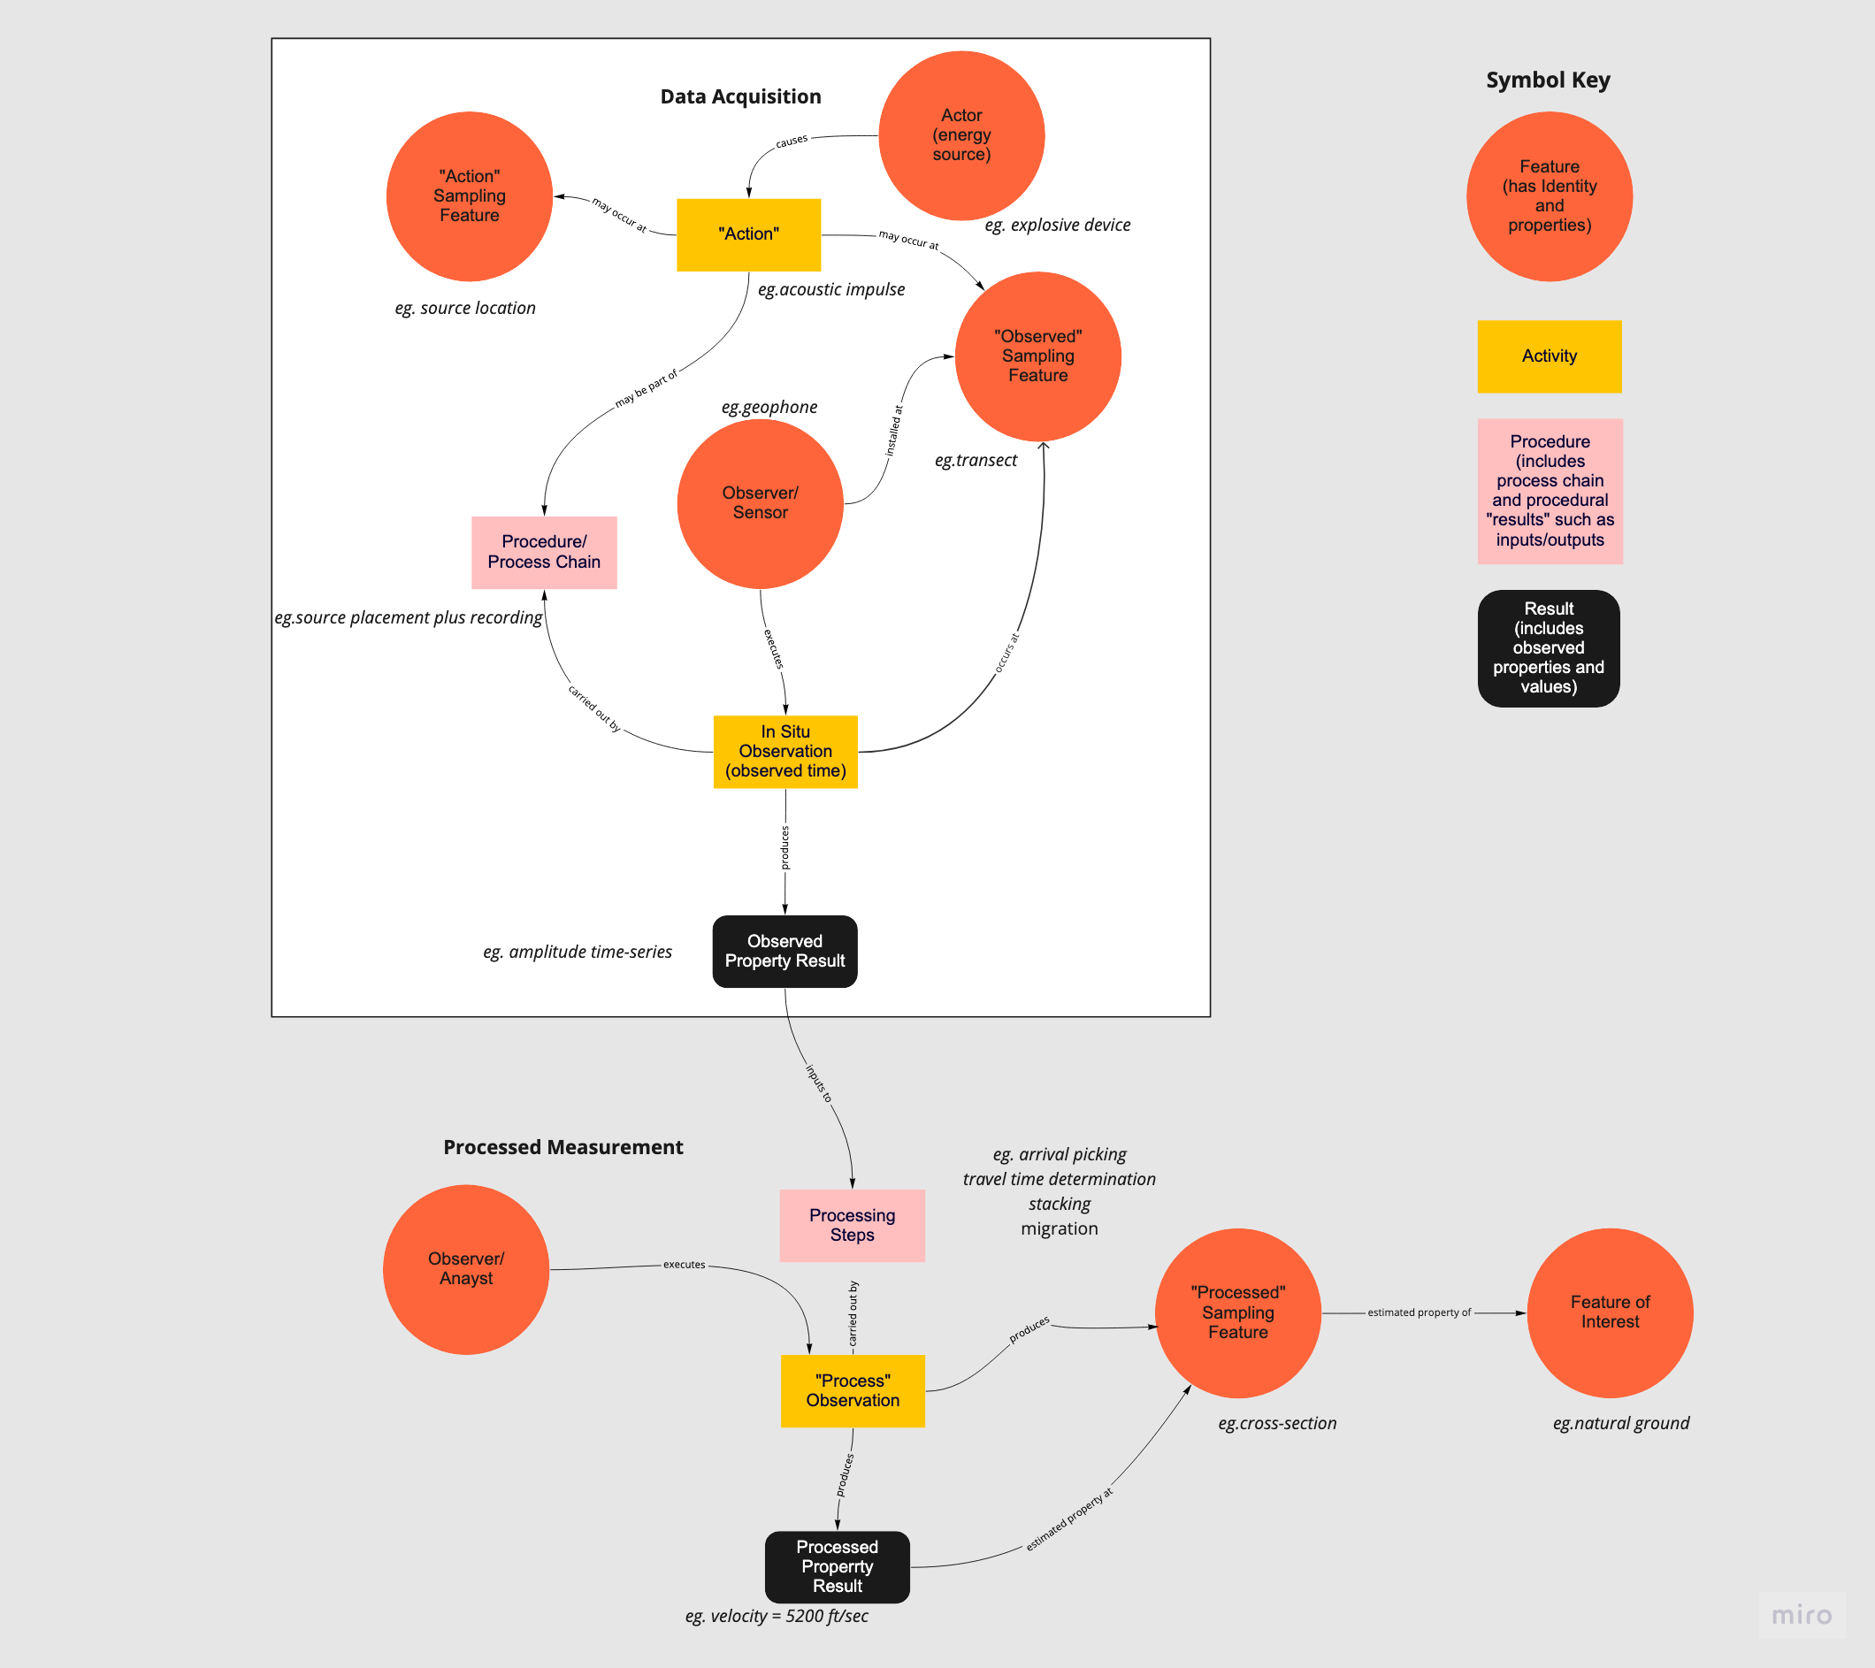

**Figure 1**. Graphical representation of a generalized data model for geophysical surveys. Field surveys can be thought of as consisting of two “measurements” – a data acquisition” measurement, that produces measured parameters collected directly in the field, and a “processed measurement”, that uses the field results to produce a final result that is an estimate of a property of the feature of interest. During data acquisition, a sensor, or sensors, is distributed or moved across some geographical sampling space and measures some parameter (the observed property). This observation may involve an active source or sources, that could be distributed across some different geographic space. Typically, the property measured during data acquisition, such as a wave-amplitude time-series, is not the property of ultimate interest. The “processed” measurement, occurs when the parameters measured during data acquisition are analyzed via processing steps to produce a final processed result that is the value of a different property (eg. seismic velocity) distributed across a sampling space that may be different from those used for data acquisition. This processed result serves as an estimated property for the feature of interest (eg. a volume or slice through the natural ground).

Overview of the DIGGS Data Model

DIGGS defines a structure that describes real-world objects and activities and their relations within the geotechnical discipline. Data are stored as ASCII text in eXtensible Markup Language (XML) format that:

1. conforms to Geographic Markup Language (GML) standards for defining objects, properties, and geometries for location-based geotechnical data, and
2. defines data objects, object properties, and their associations.

As defined by the DIGGS schema, DIGGS XML instance documents consist of a collection of XML elements that fall within one of the following top-level object classes:

* **Project** - a business activity that encompasses a collection of sampling features, activities, samples, observations, and measurements. A project may occur at a physical location, in which case it can optionally contain geometries. A project is typically associated with an investigation or construction activity for which there a specific outcome anticipated such as a research publication, design, or an actual geotechnical construction (eg. deep foundation, earthwork, etc.).
* **SamplingFeature** – a physical object or location through which we observe or measure properties of an investigation target or perform some type of activity. Investigation targets can be real world objects, such as natural ground, ground water, a pipeline - or the reason for an activity, such as ground improvement. Boreholes, soundings, and trial pits are specialized examples of sampling features. A sampling feature serves to define the dimensionality, extent, and local spatial reference system for zones where observations or activities take place. All sampling features have properties that define their geographic location and geometries such that observations and measurements obtained from them can be precisely located.
* **Installation** – a type of sampling feature that is installed within another sampling feature; its geometry is confined to that of the parent sampling feature. A piezometer installed in a borehole is a specialized example of an installation.
* **Sampling Activity** - the action taken to obtain or produce a material sample, even if the action produces no sample (eg. a core run from which there is no recovery). This activity typically occurs at a location on a sampling feature or could occur elsewhere, such as in a laboratory.
* **Sample** – a material sample, either solid, fluid, or gas, that results from a sampling activity for the purpose of observation and/or testing.
* **ObservationSystem** – a qualitative or category-based description or interpretation obtained within the context of a sampling feature or a sample. Common observations are soil descriptions and field classifications as would be reported on a boring log, descriptions of the character and geometry of fractures or geologic structures, or interpretations that derive from such descriptions, such as geologic formation assignments or geotechnical units.
* **Measurement** – an act or event whose results are quantitative estimates of the values of properties of the target of an investigation. DIGGS currently has three specialized measurement objects, 1) a Test, which is a measurement made over a spatial domain, such as laboratory tests on samples collected in the field, or in-situ tests where measurements are made directly on site, 2) monitoring activities (Monitor), which are measurements made over a temporal domain, such as water level measurements or inclinometer readings, and 3) a MaterialTest, which is for measurements made on material samples that are manufactured such that the result pertains only to the sample and not to any associated location. Examples of these would be test results on aggregated samples used for fill or on a sample of a grout mix to be used in a grouting activity.
* **Group –** a logical collection of projects, sampling features, or samples.
* **ConstructionActivity –** a new object class proposed in DIGGS v.2.6-dev, used for actions taken to improve or alter ground conditions.
* **Program –** another new object class for DIGGS 2.6-dev that contains design plans, specifications, and performance requirements for construction and exploration activities.

Specialized members of these object classes are represented within a DIGGS instance document as XML elements of complex type – meaning that they contain nested XML elements within them; these nested elements are called properties. DIGGS properties may themselves also contain nested component objects in accordance with GML’s object-property rule (Example 1).

The various object classes described above each contain an abstract base object and specialized objects that derive directly from the abstract base. This inheritance architecture allows objects of a similar class to share a common set of properties and is used to constrain how various objects are organized within a DIGGS instance document. Extending the DIGGS schema involves creating new specialized objects that inherit properties from the abstract objects of one of these classes.

Example 1. Basic structure of a DIGGS object



As shown in Figure 2, each object class associates with other object classes in various ways. As an example, every Borehole object (a specialized sampling feature) must be associated with a Project object. This is accomplished in the XML by means of a mandatory referencing property in the Borehole object that holds the ID of the associated Project. Similarly, Sample, ObservationSystem and Measurement objects carry properties that reference the sampling feature from which they are obtained, where applicable. The specific locations of samples, observation systems and measurements may also be defined within the sampling feature’s internal spatial reference system. The modularity of DIGGS’ schema design allows for significant flexibility for how various data associations are modeled and allows the same features to be utilized in different contexts. For example, the same Sample object structure is used to describe a material sample whether it is derived from a borehole, a trial pit, or another sample; the context is defined by the values held in the sample’s referencing properties.

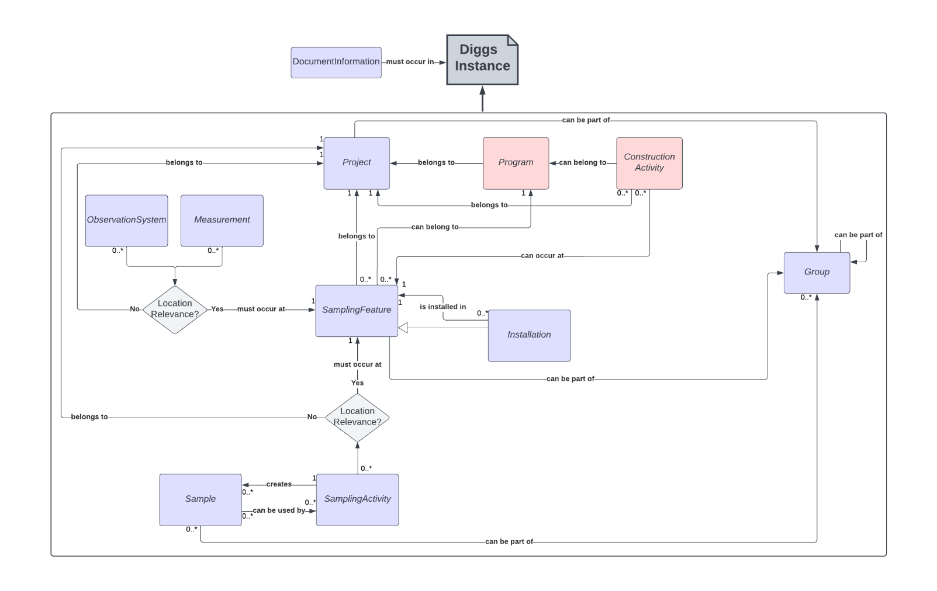

**Figure 2.** High-level Unified Modeling Language (UML) diagram of the DIGGS data model, showing the associations between the major classes of objects (boxes). Pink boxes are proposed new object classes in development to support construction activities such as grouting and pile installation and testing. Proposed extensions to include support for geophysical data involve the creation or modification of specialized objects within the Measurement and SamplingFeature object classes.

Proposed DIGGS Schema Extensions

Extending DIGGS to accommodate processed geophysical data involves both modifications to, and the addition of, objects within the SamplingFeature and Measurement object classes. These extensions focus on:

* Accommodating the distribution of measurement results within 2D and 3D spatial domains.
* Providing a way for future linkage of geophysical processed measurements to “data acquisition” measurements.
* Adding a procedure object to describe the processing steps taken to derive the processed results from raw data.
* Providing a means to compactly encode gridded data.

New objects can be found at <https://diggsml.org/schemas/2.6> in the Geophysics.xsd schema file. Schema documentation is located at <https://diggsml.org/docs/2.6> and example files can be found at <https://github.com/DIGGSml/diggs-examples/tree/master/2.6%20Example%20instances>.

### ***Extensions to the SamplingFeature object class***

Processed geophysical measurements relate to locations in geographic space and as such must be associated with a sampling feature that describes the extent and geometry of the region being “sampled” by the geophysical measurements. All sampling features derive from the AbstractSamplingFeature base object. Figure 3 shows a generalized Unified Modeling Language (UML) diagram that illustrates this object and those that derive from it. Abstract objects are shown in Figure 3 with names in bold, italicized text that start with “Abstract”. Abstract objects do not appear in instance documents but serve to hold properties (listed in Figure 3 below the object name in lower camel-case text) that are shared by all concrete objects (shown in Figure 3 in bold, unitalicized text) that derive from them.

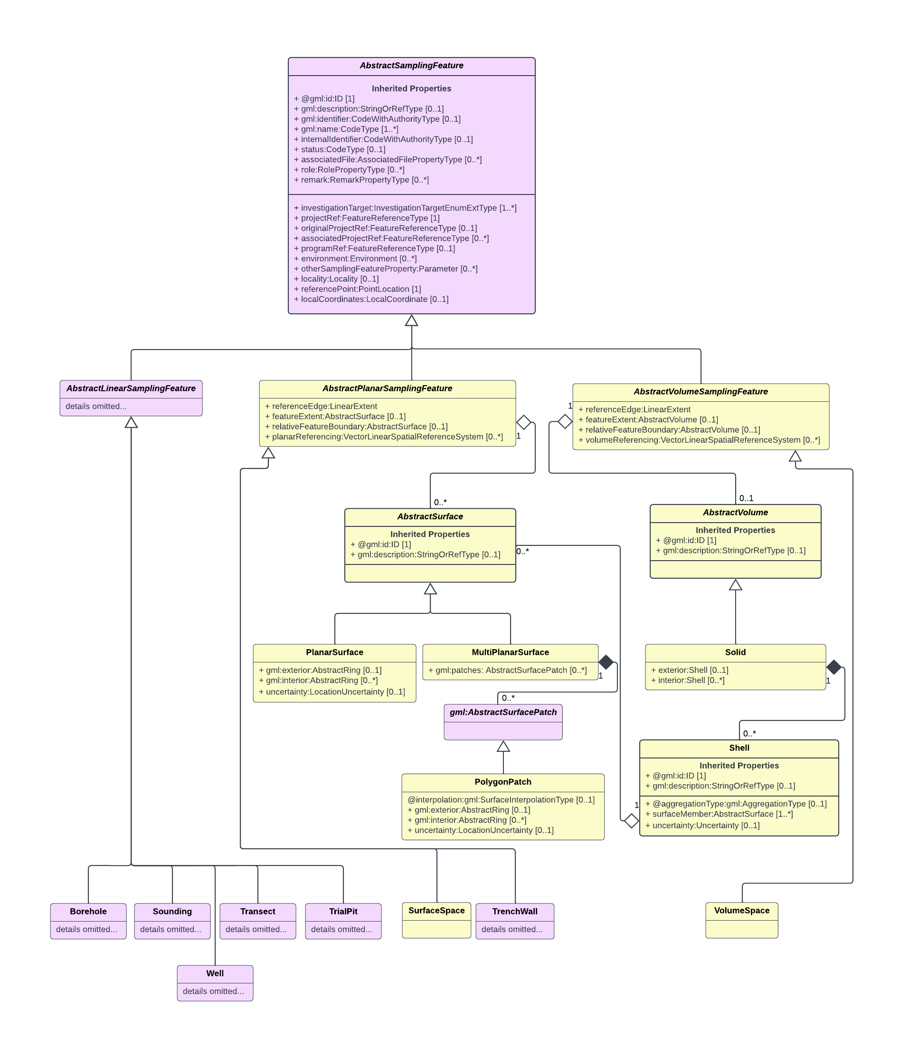

**Figure 3**. Generalized UML diagram of the SamplingFeature class. Objects in yellow are those that have been added or updated for this extension; those in purple are pre-existing and remain unmodified. Some pre-existing component objects have been omitted from the diagram for visual clarity. Association symbology: open triangle=inheritance/generalization, triangle points to the parent (generalized) object; open diamond=aggregation, diamond points to the parent object, child object is a component of the parent object, but its existence does not depend on the existence of the parent; closed diamond=composition, diamond points to the parent object, child object is a component of the parent object, and its existence depends on the existence of the parent.

As shown in Figure 3, the AbstractSamplingFeature base type is further specialized into other abstract objects based on the dimensionality of the sampling feature’s geometry. AbstractLinearSamplingFeature is used as the base type for specialized sampling features whose geometries are modeled as 1D objects (lines), such as boreholes, soundings, or transects. The current DIGGS schema has mostly focused on developing linear sampling features, most importantly the borehole sampling feature. Processed measurements from borehole geophysical surveys, such as wireline logs and single borehole seismic experiments that produce results related to distance along the borehole path, would utilize the Borehole object as its associated sampling feature.

#### 2-dimensional sampling features

Sampling features that can be modeled as 2D objects derive from AbstractPlanarSamplingFeature. This abstract feature was initially envisioned by DIGGS to support the modeling of sampling features that comprise a single planar surface whose extent is defined by a polygon with vertices that are all coplanar. One specialization of this type of sampling feature, the TrenchWall, has already been developed. TrenchWall inherits all of these geometric properties plus has additional properties relevant to the construction of a trench.

As originally conceived, AbstractPlanarSamplingFeature is a suitable base type for horizontal, 2D representations, such as map views and for 2D vertical cross-sections if the sections can be represented by a single planar surface. To accommodate cross-sectional representations on dogleg or curved sections, we have modified and extended AbstractPlanarSamplingFeature to handle both single and multi-planar surface types and have created a specialized SurfaceSpace concrete sampling feature for use with 2D geophysical surveys where data are represented in map or cross-section view. The SurfaceSpace sampling feature derives from AbstractPlanarSamplingFeature with no additional properties.

The SurfaceSpace geometry and extent are defined by the following properties (Figures 4 and 5):

* **referencePoint:** a point (PointLocation geometry object) that represents the origin location of the SurfaceSpace described in a well-known 2D or 3D geographic or projected coordinate reference system (CRS)
* **referenceEdge:** a line (LinearExtent geometry object), whose vertices are described in the same CRS as the referencePoint, that runs through the reference point along one edge of the SurfaceSpace’s surface. It is used to define the x-axis of the SurfaceSpace’s 2D vector linear spatial reference system (SRS).
* **featureExtent:** a region that defines the limits of the SurfaceSpace. featureExtent is defined by either a PlanarSurface geometry object (an extension of gml:Polygon) or a MultiPlanarSurface geometry object (an extension of gml:Surface). A MultiPlanarSurface consists of two or more planar surface patches (PolygonPatch geometry objects) that adjoin each other to form a continuous surface. Coordinates of the vertices that form the geometry objects of the featureExtent are described in a well-known 2D or 3D geographic or projected CRS.
* **relativeFeatureBoundary:** this property serves the same purpose as featureExtent except that the coordinates of the surface vertices are described by the SurfaceSpace’s 2D SRS, if one is defined.



**Figure 4**. An example of a multi-planar SurfaceSpace feature as a vertical surface, showing a graphical representation of resistivity within the sampled space. The feature extent of the SurfaceSpace bounds the data and is composed of five polygon patches (white dashed lines) that bound the planar surfaces that make up the entire feature extent. Also shown are properties that define the vector linear spatial reference system for the SurfaceSpace: 1) the reference point, which defines origin of the feature in geographic space, 2) the reference edge, a line that provides one boundary for the feature and is the x-direction axis; here it lies along the feature’s top edge and is collocated with the resistivity sensor array, and 3) the offset vector, a unit vector that defines the direction of the y axis and also fixes the orientation of the surface in space. The location of any point on the SurfaceSpace can then be described by the coordinates (r,v) where r is the distance along the reference edge from the origin, and v is the distance along the vector orientation. Black circle shows the location on the sampling feature at coordinate (r1,v1).



**Figure 5.** Illustration of a single planar SurfaceSpace as a horizontal 2D surface (map), showing a graphical representation of magnetic field strength within the sampled space. The feature extent of the sampling feature bounds the data (thick black line) and is composed of a single polygon. Also shown are properties that define the vector linear spatial reference system for the SurfaceSpace, as described in Figure 4.

It is common when reporting the results of in-situ test procedures or geophysical measurements to describe the data locations as distances from an origin point along various orthogonal axes, as opposed to reporting the absolute geographic or projected coordinate location. For example, measurements in a borehole are typically referenced to distance (or measured depth) along the borehole path from the top of the hole (a 1D spatial reference system). 2D geophysical cross-sections typically show data locations defined by distance along the x-axis from an origin point, and elevation or depth along the vertical or y-axis (2D coordinate reference system). The process of defining a relative spatial reference system from absolute geographic coordinates is called linear referencing (1D coordinates) or vector linear referencing (2D or 3D coordinates). In the AbstractPlanarSamplingFeature, from which SurfaceSpace derives, the vector linear referencing parameters are defined by the planarReferencing property and its enclosed VectorLinearSpatialReferencingSystem object (Figure 6).

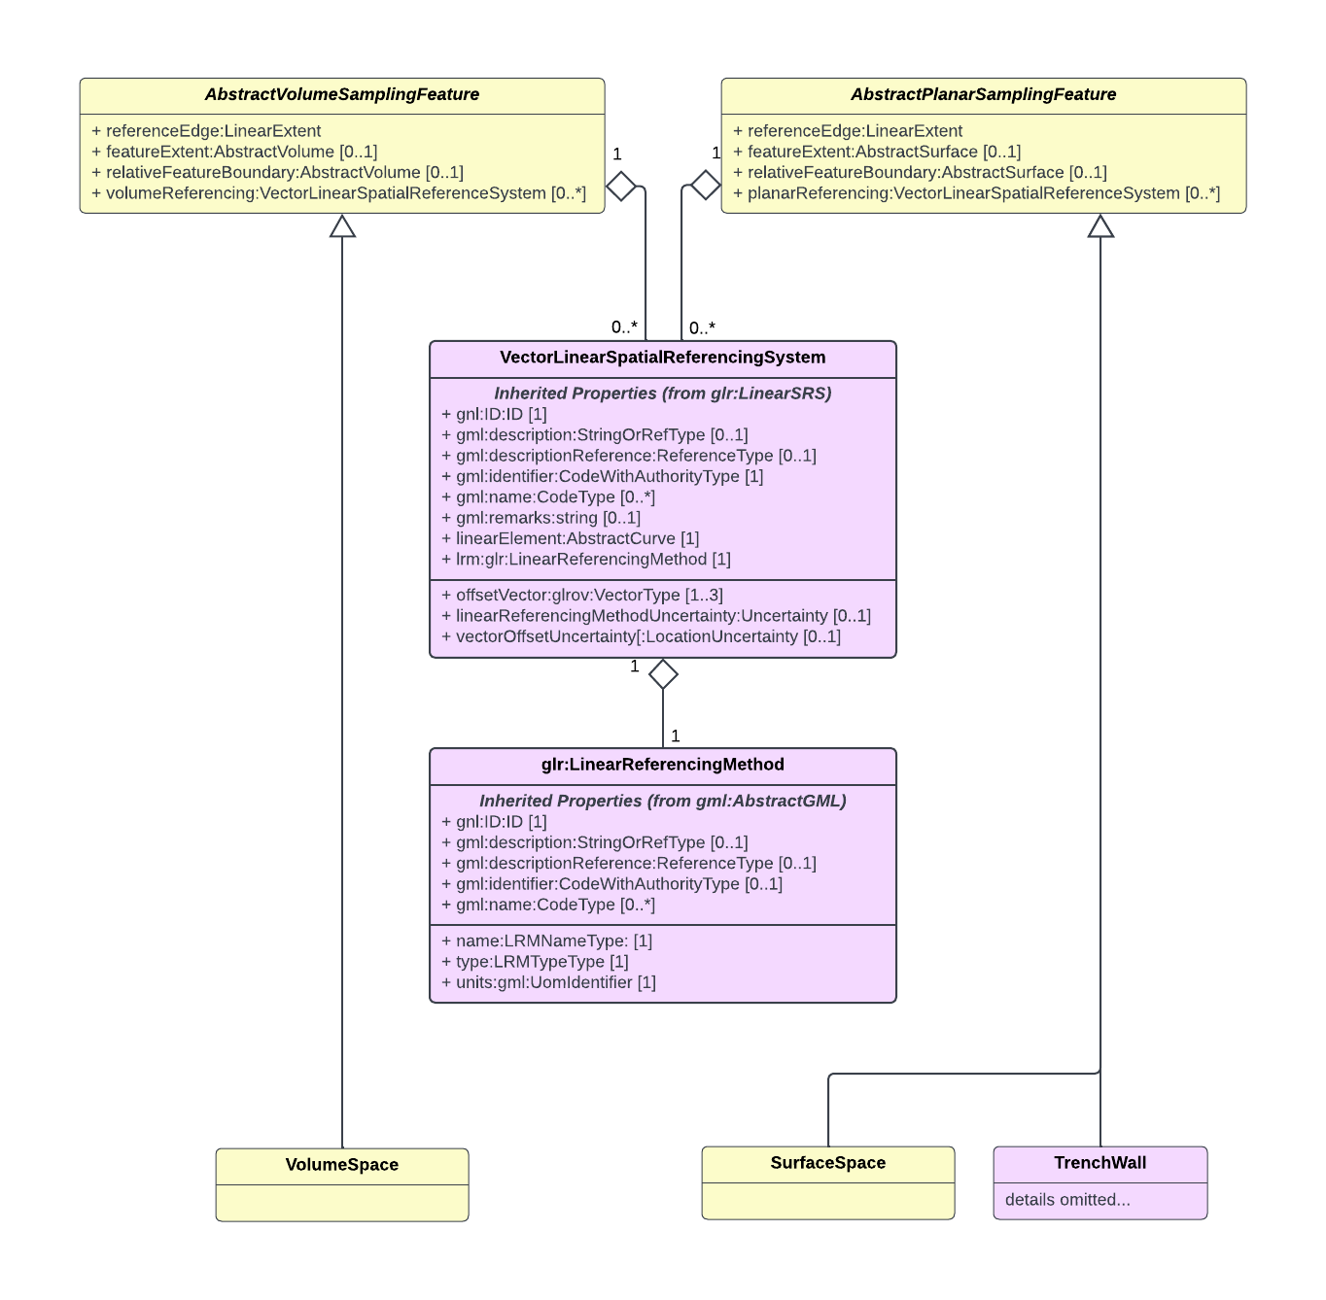

**Figure 6.** UML model showing details of the component vector linear spatial referencing objects that allow for defining relative coordinate systems for sampling features that derive from AbstractPlanarSamplingFeature or AbstractVolumeSampingFeature. Vector linear spatial referencing provides a means of defining a location within a 2D planar sampling feature by a simpler 2D coordinate that records the distance from the feature origin along the reference edge and the offset vector direction instead of its 3D geographic coordinate. Similarly, for volume sampling features, vector linear referencing allows for a location in the sampling feature to be defined by relative distance coordinates, rather than by geographic coordinates.

As shown in Figure 6, this object derives from glr:LinearSRS (GML v.3.3) and contains the following mandatory properties:

* **gml:Identifier:** an identifier for this SRS
* **linearElement**: a pointer to the linear geometry object that in this context would be the x-coordinate axis. This property would therefore point to the LinearExtent object’s identifier contained within a sampling feature’s referenceEdge property.
* **lrm**: the method used to measure along the linear element. This is defined by a GML 3.3 object with three mandatory properties: 1) name, 2) type and 3) units. In the context we are using linear referencing in DIGGS, the values for name and type are typically “chainage” and “absolute” respectively, and the units property defines the length unit of measure, typically m (for meters) or ft (for ft/US).
* **offsetVector**: a unit vector that defines the orientation of the SurfaceSpace in space and also defines the direction of the y-coordinate axis. The offset vector extends from the SurfaceSpace’s reference edge and is defined in 3D space, with each vector component defining the x, y, and z orientations of the SRS. Example 2 shows how various offset vector orientations are encoded in XML. A VectorLinearSpatialReferenceSystem defined for a SurfaceSpace requires exactly one offset vector.

Example 2. Sample offset vector instances

<offsetVector>1 0 0</offsetVector> <!—Horizontal surface, positive east -->

<offsetVector>0 -1 0</offsetVector> <!— Horizontal surface, positive south -->

<offsetVector>0 0 1</offsetVector> <!— Vertical surface, positive up -->

<offsetVector>0 0 -1</offsetVector> <!— Vertical surface, positive down -->

Once defined, the location of any point on the sampling feature can then be described by the coordinates (r,v) where r is the distance along the reference edge from the origin, and v is the distance along the vector orientation.

These described extensions to AbstractPlanarSamplingFeature allows the specialized SurfaceSpace sampling feature object to be associated with any processed geophysical measurement where the results are located within a 2D spatial domain. Once a local SRS is defined, measurement locations can use the linear SRS by referencing the ID of the defined VectorLinearSpatialReferenceSystem object in the srsName attribute of any geometry object. The following examples show how a SurfaceSpace sampling feature is encoded to define a simple vertical cross-section, a 2D map feature, and a dogleg (multi-planar) cross-section:

Example 3. SurfaceSpace sampling feature object for a simple 2D vertical cross-section defined by a feature extent consisting of one coplanar surface.

<SurfaceSpace gml:id="a22">  
 <gml:name>Cross-section A-A'</gml:name>  
 <investigationTarget>Natural Ground</investigationTarget>  
 <projectRef xlink:href="#p1"/>  
 <referencePoint>

<!—CRS is compound UTM Zone 11 North NAD83 and NAVD88 elevation-->  
 <PointLocation srsName="urn:diggs:def:crs:DIGGS:0.1:26911_5703" srsDimension="3"  
 gml:id="a34">  
 <gml:pos>387516.665116977 3742645.12297961 5</gml:pos>  
 </PointLocation>  
 </referencePoint>  
 <referenceEdge>  
 <LinearExtent srsName="urn:diggs:def:crs:DIGGS:0.1:26911_5703" srsDimension="3"  
 gml:id="ply1_top">  
 <gml:posList>387516.665116977 3742645.12297961 5 387546.665116977  
 3742685.12297961 5 </gml:posList>  
 </LinearExtent>  
 </referenceEdge>  
 <!--featureExtent and/or relativeFeatureBoundary may be used to define the feature extent.   
 featureExtent must be used if no linear spatial reference system is defined for the sampling feature -->  
 <featureExtent>  
 <PlanarSurface srsName="urn:diggs:def:crs:DIGGS:0.1:26911_5703" srsDimension="3"  
 gml:id="ply2">  
 <gml:exterior>  
 <gml:LinearRing>  
 <gml:posList>387516.665116977 3742645.12297961 5 387546.665116977  
 3742685.12297961 5 387546.665116977 3742685.12297961 -5  
 387516.665116977 3742645.12297961 -5 387516.665116977  
 3742645.12297961 5</gml:posList>  
 </gml:LinearRing>  
 </gml:exterior>  
 </PlanarSurface>  
 </featureExtent>  
 <relativeFeatureBoundary>  
 <PlanarSurface srsDimension="2" srsName="#lsrs002" gml:id="ply1">  
 <gml:exterior>  
 <gml:LinearRing>  
 <gml:posList>0 0 50 0 50 10 0 10 0 0</gml:posList>  
 </gml:LinearRing>  
 </gml:exterior>  
 </PlanarSurface>  
 </relativeFeatureBoundary>  
 <planarReferencing>  
 <VectorLinearSpatialReferenceSystem gml:id="lsrs002">  
 <gml:identifier codeSpace="DIGGS">lsrs002</gml:identifier>  
 <glr:linearElement xlink:href="#ply1_top"/>  
 <glr:lrm>  
 <glr:LinearReferencingMethod gml:id="lrm-lsrs002">  
 <glr:name>chainage</glr:name>  
 <glr:type>absolute</glr:type>  
 <glr:units>m</glr:units>  
 </glr:LinearReferencingMethod>  
 </glr:lrm>  
 <offsetVector>0 0 -1</offsetVector>  
 </VectorLinearSpatialReferenceSystem>  
 </planarReferencing>  
 </SurfaceSpace>

Example 4. SurfaceSpace sampling feature object for a simple 2D horizontal surface

(map view, where only 2D geographic coordinates are needed)

<SurfaceSpace gml:id="map1">  
 <gml:name>Map View</gml:name>  
 <investigationTarget>Natural Ground</investigationTarget>  
 <projectRef xlink:href="#p1"/>  
 <!—CRS is UTM Zone 11 North NAD83 datum (EPSG code 26911)-->  
 <referencePoint>  
 <PointLocation srsName="http://www.opengis.net/def/crs/EPSG/0/26911"  
 srsDimension="2" gml:id="a35">  
 <gml:pos>387516 3742645</gml:pos>  
 </PointLocation>  
 </referencePoint>  
 <referenceEdge>  
 <LinearExtent srsName="http://www.opengis.net/def/crs/EPSG/0/26911" srsDimension="2"  
 gml:id="lower_edge">  
 <gml:posList>387516 3742645 387546 3742645</gml:posList>  
 </LinearExtent>  
 </referenceEdge>  
 <featureExtent>  
 <PlanarSurface srsName="http://www.opengis.net/def/crs/EPSG/0/26911"  
 srsDimension="2" gml:id="ply4">  
 <gml:exterior>  
 <gml:LinearRing>  
 <gml:posList>387516 3742645 387546 3742645 387546 3742685 387516 3742685  
 387516 3742645</gml:posList>  
 </gml:LinearRing>  
 </gml:exterior>  
 </PlanarSurface>  
 </featureExtent>  
 <relativeFeatureBoundary>  
 <PlanarSurface srsDimension="2" srsName="#lsrs003" gml:id="ply3">  
 <gml:exterior>  
 <gml:LinearRing>  
 <gml:posList>0 0 30 0 30 40 0 40 0 0</gml:posList>  
 </gml:LinearRing>  
 </gml:exterior>  
 </PlanarSurface>  
 </relativeFeatureBoundary>  
 <planarReferencing>  
 <VectorLinearSpatialReferenceSystem gml:id="lsrs003">  
 <gml:identifier codeSpace="DIGGS">lsrs003</gml:identifier>  
 <glr:linearElement xlink:href="#lower_edge"/>  
 <glr:lrm>  
 <glr:LinearReferencingMethod gml:id="lrm-lsrs003">  
 <glr:name>chainage</glr:name>  
 <glr:type>absolute</glr:type>  
 <glr:units>m</glr:units>  
 </glr:LinearReferencingMethod>  
 </glr:lrm>  
 <offsetVector>0 1 0</offsetVector>  
 </VectorLinearSpatialReferenceSystem>  
 </planarReferencing>  
 </SurfaceSpace>

Example 5. SurfaceSpace sampling feature object for a simple 2D dog-leg (2 panel) vertical cross-section. (Only the relativeFeatureBoundary property is shown here; no featureExtent is necessary since linear referencing is defined for the sampling feature)

<SurfaceSpace gml:id="dogleg">  
 <gml:name>Dogleg sectipon B-B'</gml:name>  
 <investigationTarget>Natural Ground</investigationTarget>  
 <projectRef xlink:href="#p1"/>  
 <referencePoint>  
 <PointLocation srsName="urn:diggs:def:crs:DIGGS:0.1:26911_5703" srsDimension="3"  
 gml:id="dl1">  
 <gml:pos>387516 3742645 5</gml:pos>  
 </PointLocation>  
 </referencePoint>  
 <referenceEdge>  
 <LinearExtent srsName="urn:diggs:def:crs:DIGGS:0.1:26911_5703" srsDimension="3"  
 gml:id="dog1_top">  
 <gml:posList>387516 3742645 5 387546 3742685 5 387546 3742725 5</gml:posList>  
 </LinearExtent>  
 </referenceEdge>  
 <!--Only relativeFeatureBoundary is shown in this example -->  
 <relativeFeatureBoundary>  
 <MultiPlanarSurface srsName="#doglsrs001" srsDimension="2" gml:id="dog1">  
 <gml:patches>  
 <PolygonPatch interpolation="planar">  
 <gml:exterior>  
 <gml:LinearRing>  
 <gml:posList>0 0 50 0 50 10 0 10 0 0</gml:posList>  
 </gml:LinearRing>  
 </gml:exterior>  
 </PolygonPatch>  
 <PolygonPatch interpolation="planar">  
 <gml:exterior>  
 <gml:LinearRing>  
 <gml:posList>50 0 90 0 90 10 50 10 50 0</gml:posList>  
 </gml:LinearRing>  
 </gml:exterior>  
 </PolygonPatch>  
 </gml:patches>  
 </MultiPlanarSurface>  
 </relativeFeatureBoundary>  
 <planarReferencing>  
 <VectorLinearSpatialReferenceSystem gml:id="doglsrs001">  
 <gml:identifier codeSpace="DIGGS">doglsrs001</gml:identifier>  
 <glr:linearElement xlink:href="#dog1_top"/>  
 <glr:lrm>  
 <glr:LinearReferencingMethod gml:id="lrm-doglsrs001">  
 <glr:name>chainage</glr:name>  
 <glr:type>absolute</glr:type>  
 <glr:units>m</glr:units>  
 </glr:LinearReferencingMethod>  
 </glr:lrm>  
 <offsetVector>0 0 -1</offsetVector>  
 </VectorLinearSpatialReferenceSystem>  
 </planarReferencing>  
 </SurfaceSpace>

#### 3-dimensional sampling features

Some types of geophysical surveys produce estimates of physical properties within a 3D volume. To handle such types of survey results, we have created a new abstract object and one new specialized sampling feature object for defining 3D sampling spaces that represent volumes within the earth. As shown on Figure 3, the AbstractVolumeSamplingFeature, and its derived specialized sampling feature object, the VolumeSpace, have essentially the same geometry properties as 2D sampling features:

* **referencePoint: :** a point (PointLocation geometry object) that defines the origin location of the VolumeSpace described in a well-known 3D geographic or projected coordinate reference system.
* **referenceEdge:** a line in 3D space (LinearExtent geometry object), whose vertices are described in the same CRS as the referencePoint, that runs through the reference point along one edge of the VolumeSpace. It is used to define the x-axis of a 3D vector linear spatial reference system.
* **featureExtent:** a volume that defines the limits of the VolumeSpace. As opposed to 2D sampling features, the featureExtent of VolumeSpace is defined by a Solid geometry object (an extension of gml:Solid). A Solid is defined by exterior and (optionally) interior Shell geometry objects, which are 3D surfaces that define the limit of the Solid. The Shell object (Figure 3), consists of a number of surfaceMembers, each of which contains a PlanarSurface object, that adjoin each other to form a closed solid. A common and simple form of a Solid used for geophysics is a rectangular prism, which consists of an exterior shell composed of six planar surfaces that join each other at right angles (Figure 7).
* **relativeFeatureBoundary:** as with SurfaceSpace, this property serves the same purpose as featureExtent except that the coordinates of the Solid vertices are described by the VolumeSpace’s local spatial reference system (SRS), if one is defined.

Although less commonly used than for 1D or 2D sampling features, the AbstractVolumeSampingFeature object (and its derived VolumeSpace) provides a property, named volumeReferencing, to support the creation of a relative spatial reference system. The property volumeReferencing contains the same VectorLinearSpatialReferenceSystem object as for 2D sampling features, with the only difference being that a VectorLinearSpatialReferenceSystem for a VolumeSpace requires that two orthogonal offsetVector properties be defined. These offset vectors define the directions of the y and z axes respectively, and also fix the orientation of the solid in space (Figure 7). The location of any point within the sampling feature volume can then be described by the coordinates (r1,v1,v2) where r1 is the distance along the reference edge from the origin, v1 is the distance along the y-axis vector orientation, and v2 is the distance along the z-axis vector orientation



**Figure 7**. Example of a VolumeSpace 3D sampling feature, showing a graphical representation of seismic velocity within the sampled space. The feature extent of the sampling feature bounds the data and is composed of six planar surfaces (black boundary lines) that comprises the exterior shell of the solid (three surfaces shown in this perspective). Also shown are properties that define the linear spatial reference system for the sampling feature: 1) the reference point, which defines origin of the feature in geographic space, 2) the reference edge, a line string defined in geographic space that provides one boundary for the feature and is the x-direction axis, and 3) two orthogonal offset vectors, (unit vectors) that define the directions of the y and z axes and also fix the orientation of the solid in space. The location of a point within the sampling feature volume (yellow circle) can then be described by the coordinates (r1,v1,v2) where r1 is the distance along the reference edge from the origin, v1 is the distance along the y-axis vector orientation, and v2 is the distance along the z-axis vector orientation.

These described extensions to AbstractVolumeSamplingFeature and its associated objects allows the specialized VolumeSpace sampling feature object to be associated with any processed geophysical measurement where the results are located within a 3D volume. The following is an XML instance example showing how these objects can be used to define a rectangular prism sampling feature:

Example 6. VolumeSpace sampling feature object for a simple rectangular prism with an exterior shell consisting of six coplanar PlanarSurface members.

(Both the featureExtent defining the Solid in a projected CRS (UTM Zone 11 North Nad83 Datum and NAVD88 elevation in meters), and a relativeFeatureBoundary defined in the relative SRS are shown, but only one is necessary)

<VolumeSpace gml:id="vol1">  
 <gml:name>Seismic volume</gml:name>  
 <investigationTarget>Natural Ground</investigationTarget>  
 <projectRef xlink:href="#p1"/>  
 <referencePoint>  
 <PointLocation srsName="urn:diggs:def:crs:DIGGS:0.1:26911_5703" srsDimension="3"  
 gml:id="rpv">  
 <gml:pos>387516 3742645 -5</gml:pos>  
 </PointLocation>  
 </referencePoint>  
 <referenceEdge>  
 <LinearExtent srsName="urn:diggs:def:crs:DIGGS:0.1:26911_5703" srsDimension="3"  
 gml:id="rev">  
 <gml:posList>387516 3742645 -5 387546 3742645 -5</gml:posList>  
 </LinearExtent>  
 </referenceEdge>  
 <featureExtent>  
 <Solid srsName="urn:diggs:def:crs:DIGGS:0.1:26911_5703" srsDimension="3"  
 gml:id="fev">  
 <!-- A rectangular prism -->  
 <exterior>  
 <Shell aggregationType="set" gml:id="fev-shell">  
 <surfaceMember>  
 <!-- Top surface -->  
 <PlanarSurface gml:id="fev-sm1">  
 <gml:exterior>  
 <gml:LinearRing>  
 <gml:posList>387516 3742645 5 387546 3742645 5 387546  
 3742685 5 387516 3742685 5 387516 3742645  
 5</gml:posList>  
 </gml:LinearRing>  
 </gml:exterior>  
 </PlanarSurface>  
 </surfaceMember>  
 <surfaceMember>  
 <!-- Bottom surface -->  
 <PlanarSurface gml:id="fev-sm2">  
 <gml:exterior>  
 <gml:LinearRing>  
 <gml:posList>387516 3742645 -5 387546 3742645 -5 387546  
 3742685 -5 387516 3742685 -5 387516 3742645  
 -5</gml:posList>  
 </gml:LinearRing>  
 </gml:exterior>  
 </PlanarSurface>  
 </surfaceMember>  
 <surfaceMember>  
 <!-- Western vertical surface -->  
 <PlanarSurface gml:id="fev-sm3">  
 <gml:exterior>  
 <gml:LinearRing>  
 <gml:posList>387516 3742645 -5 387516 3742685 -5 387516  
 3742685 5 387516 3742645 5 387516 3742645 -5  
 </gml:posList>  
 </gml:LinearRing>  
 </gml:exterior>  
 </PlanarSurface>  
 </surfaceMember>  
 <surfaceMember>  
 <!-- Eastern vertical surface -->  
 <PlanarSurface gml:id="fev-sm4">  
 <gml:exterior>  
 <gml:LinearRing>  
 <gml:posList>387546 3742645 -5 387546 3742685 -5 387546  
 3742685 5 387546 3742645 5 387546 3742645 -5  
 </gml:posList>  
 </gml:LinearRing>  
 </gml:exterior>  
 </PlanarSurface>  
 </surfaceMember>  
 <surfaceMember>  
 <!-- Northern vertical surface -->  
 <PlanarSurface gml:id="fev-sm5">  
 <gml:exterior>  
 <gml:LinearRing>  
 <gml:posList>387516 3742685 -5 387546 3742685 -5 387546  
 3742685 5 387516 3742685 5 387516 3742685 -5  
 </gml:posList>  
 </gml:LinearRing>  
 </gml:exterior>  
 </PlanarSurface>  
 </surfaceMember>  
 <surfaceMember>  
 <!-- Southern vertical surface -->  
 <PlanarSurface gml:id="fev-sm6">  
 <gml:exterior>  
 <gml:LinearRing>  
 <gml:posList>387516 3742645 -5 387546 3742645 -5 387546  
 3742645 5 387516 3742645 5 387516 3742645 -5  
 </gml:posList>  
 </gml:LinearRing>  
 </gml:exterior>  
 </PlanarSurface>  
 </surfaceMember>  
 </Shell>  
 </exterior>  
 </Solid>  
 </featureExtent>  
 <relativeFeatureBoundary>  
 <!-- Same solid using relative reference system coordinates -->  
 <Solid srsName="#vsrs001" srsDimension="3" gml:id="rfbv">  
 <exterior>  
 <Shell aggregationType="set" gml:id="rfvb-shell">  
 <surfaceMember> <!-- Top surface -->  
 <PlanarSurface gml:id="rfbv--sm1">  
 <gml:exterior>  
 <gml:LinearRing>  
 <gml:posList>0 0 5 30 0 5 30 40 5 0 40 5 0 0 5</gml:posList>   
 </gml:LinearRing>  
 </gml:exterior>  
 </PlanarSurface>  
 </surfaceMember>  
 <surfaceMember> <!-- Bottom surface -->  
 <PlanarSurface gml:id="rfbv--sm2">  
 <gml:exterior>  
 <gml:LinearRing>  
 <gml:posList>0 0 -5 30 0 -5 30 40 -5 0 40 -5 0 0 -5</gml:posList>   
 </gml:LinearRing>  
 </gml:exterior>  
 </PlanarSurface>  
 </surfaceMember>  
 <surfaceMember> <!-- Western vertical surface -->  
 <PlanarSurface gml:id="rfbv--sm3">  
 <gml:exterior>  
 <gml:LinearRing>  
 <gml:posList>0 0 -5 0 40 -5 0 40 5 0 0 5 0 0 -5</gml:posList>   
 </gml:LinearRing>  
 </gml:exterior>  
 </PlanarSurface>  
 </surfaceMember>  
 <surfaceMember> <!-- Eastern vertical surface -->  
 <PlanarSurface gml:id="rfbv--sm4">  
 <gml:exterior>  
 <gml:LinearRing>  
 <gml:posList>30 0 -5 30 40 -5 30 40 5 30 0 5 30 0 -5</gml:posList>   
 </gml:LinearRing>  
 </gml:exterior>  
 </PlanarSurface>  
 </surfaceMember>  
 <surfaceMember> <!-- Northern vertical surface -->  
 <PlanarSurface gml:id="rfbv--sm5">  
 <gml:exterior>  
 <gml:LinearRing>  
 <gml:posList>0 40 -5 30 40 -5 30 40 5 0 40 5 0 40 -5</gml:posList>   
 </gml:LinearRing>  
 </gml:exterior>  
 </PlanarSurface>  
 </surfaceMember>  
 <surfaceMember> <!-- Southern vertical surface -->  
 <PlanarSurface gml:id="rfbv--sm6">  
 <gml:exterior>  
 <gml:LinearRing>  
 <gml:posList>0 0 -5 30 0 -5 30 0 5 0 0 5 0 0 -5</gml:posList>   
 </gml:LinearRing>  
 </gml:exterior>  
 </PlanarSurface>  
 </surfaceMember>  
 </Shell>  
 </exterior>  
 </Solid>  
 </relativeFeatureBoundary>  
 <volumeReferencing>  
 <VectorLinearSpatialReferenceSystem gml:id="vsrs001">  
 <gml:identifier codeSpace="DIGGS">vsrs001</gml:identifier>  
 <glr:linearElement xlink:href="#rev"/>  
 <glr:lrm>  
 <glr:LinearReferencingMethod gml:id="lrm-vfe">  
 <glr:name>chainage</glr:name>  
 <glr:type>absolute</glr:type>  
 <glr:units>m</glr:units>  
 </glr:LinearReferencingMethod>  
 </glr:lrm>  
 <offsetVector>0 1 0</offsetVector> <!-- Offset vector pointing north for y coordinate direction -->  
 <offsetVector>0 0 1</offsetVector> <!-- Offset vector pointing up for z doordinate direction -->  
 </VectorLinearSpatialReferenceSystem>  
 </volumeReferencing>  
 </VolumeSpace>

### ***Extensions to the Measurement object class***

Processed results from geophysical surveys where the results relate to physical locations in the earth can be handled without much modification by DIGGS’ existing Test object, one of three currently defined major objects of the Measurement object class.

As shown in Figure 8, the Test object derives from AbstractMeasurement, which provides metadata and referencing properties common to all DIGGS measurements. The Test object itself adds three properties to record the relevant time for the test (samplingTime), when the test result became available (resultTime), and during what time the results are considered valid (validTime). The outcome property holds the TestResult object, where the results are reported, and the procedure property holds a specialized Procedure object that provides details on how the Test was performed.

In the TestResult object, the location property holds a geometry object that carries the spatial locations for one or more result values. The results property holds a ResultSet object that has a property that identifies the measured properties being reported (parameters), whereas the values for each of the measured properties are listed as tuples within a text block (datavalues), where each tuple maps in order to the individual locations reported in the location property’s geometry object.

Many processed geophysical datasets contain numerous result values that have been gridded such that the result locations occur at regularly spaced intervals. To accommodate this structure and ensure the most compact encoding possible, we have added a new RectifiedGrid object to DIGGS, derived from gml:RectifiedGrid, along with a gridMappingFunction property added to the TestResult object to facilitate the encoding of gridded geophysical datasets.

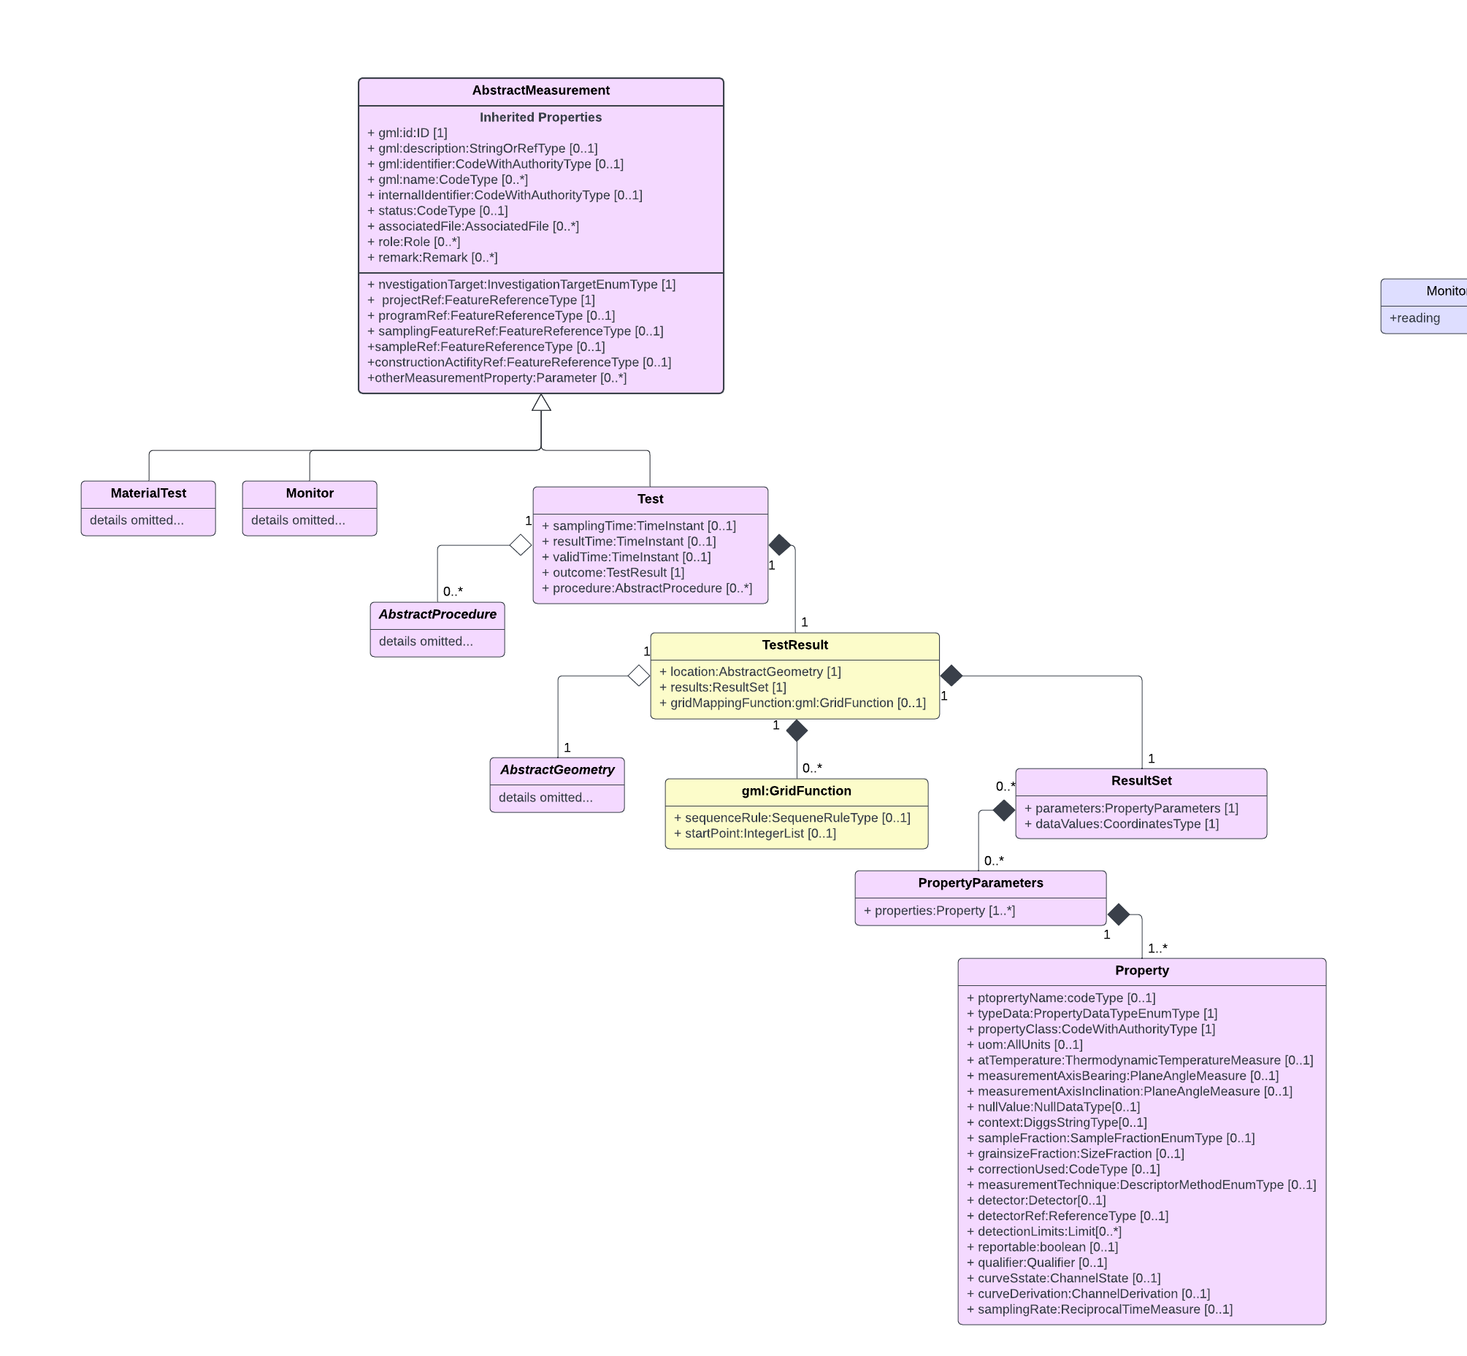

**Figure 8**. Generalized UML diagram of the Measurement class of objects. The TestResult component of the Test object is used to report results of measurements located within a spatial domain. Objects in yellow are those that have been added or updated for this extension; those in purple are pre-existing and remain unmodified. Some composite objects and object details have been removed for clarity.

Figure 9 shows a UML model for the RectifiedGrid object. Mandatory RectifiedGrid properties are:

* **dimension (**attribute): an integer defining the dimensionality of the grid
* **limits**: a property containing a component GridEnvelope object with properties that define the posted node at the lowest and highest positions on the grid.
* **axisLabels or axisName**: labels for the grid axes.
* **origin**: the location in an absolute CRS or relative or local SRS defining the grid origin.
* **offsetVector**: a vector that defines the orientation and distance between grid nodes. One vector must be defined for each dimension of the grid (i.e.. a 3D grid will have three offsetVector properties).

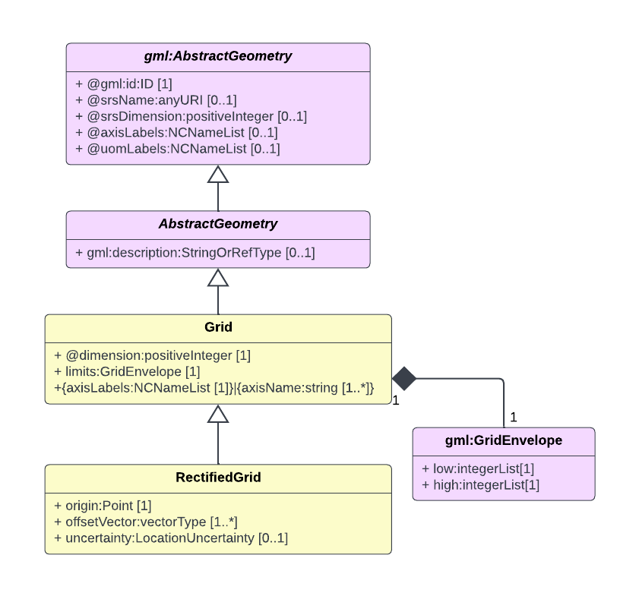

**Figure 9**. Generalized UML diagram of the RectifiedGrid object in DIGGS as derived and specialized from GML. Objects in yellow are added or updated for this extension and some pre-existing component objects have been omitted for visual clarity. The RectifiedGrid is a geometry object that can be used for the <location> property in DIGGS’ Test object. Its properties provide for very compact coding for large numbers of regularly spaced locations in 1-dimensional, 2-dimensional, or 3 dimensional spaces.

The gml:GridFunction object contained within the TestResult’s gridMappingFunction property explicitly describes the mapping of the grid nodes to the property values in the dataValues property. If gridMappingFunction is omitted, the default incrementation order starts at the low point of all axes (low limit location) and increments along the first axis (v1 direction) to its high point, then increments one position on the second axis (v2 direction) before iterating again on the first axis and so forth. Using the example in Figure 10, the default incrementation order would be [2 1],[3 1],[4 1],[5 1],[6 1],[7 1],[2 2],[3 2],[4 2],[5 2],[6 2],[7 2],[2 3],[3 3],[4 3]… etc. Specific instructions on the use of gml:GridFunction properties to define non-default mappings can be found in Open GeoSpatial Constortium (2016).



**Figure 10**. Example of a 2D rectified grid with a non-zero low limit showing its components. Small open circles represent the grid nodes, O is the grid origin location, v1, v2 are the grid offset vectors, [2 1] is the grid low limit and [7 4] is the grid high limit. Shaded rectangle shows the full extent of the gridded region. Values on the axes are easting and northing coordinates in the UTM Zone 11N CRS, NAD83 datum.

The following example provides a DIGGS XML instance of a TestResult object that uses the RectifiedGrid object:

Example 7. TestResult object from a processed aeromagnetic survey using RectifiedGrid as the geometry object, based on the grid example in Figure 10.

(The <gridMapFunction> property shown need not be used here as it contains the default values for gml:sequenceRule and gml:startPoint.)

<TestResult gml:id="amtr1">  
 <location>   
 <RectifiedGrid gml:id="amg1" dimension="2">

<limits>

<gml:GridEnvelope>

<gml:low>2 1</gml:low>

<gml:high>7 4</gml:high>

</gml:GridEnvelope>

</limits>

<axisLabels>easting northing</axisLabels>

<origin>

<gml:Point gml:id="q123">

<gml:pos srsName="http://www.opengis.net/def/crs/EPSG/0/26911"

srsDimension="2">380300 3745100</gml:pos>

</gml:Point>

</origin>

<offsetVector srsName="http://www.opengis.net/def/crs/EPSG/0/26911"

srsDimension="2">100 25</offsetVector>

<offsetVector srsName="http://www.opengis.net/def/crs/EPSG/0/26911"

srsDimension="2">-25 100</offsetVector>

</RectifiedGrid>

</location>  
 <results>  
 <ResultSet>  
 <parameters>  
 <PropertyParameters gml:id="ampp">  
 <properties>  
 <Property index="1" gml:id="p1">  
 <propertyName>residual magnetic field</propertyName>  
 <typeData>double</typeData>  
 <propertyClass codeSpace="DIGGS">magnetic_field_intensity_residual</propertyClass>  
 <uom>nT</uom>  
 </Property>  
 </properties>  
 </PropertyParameters>  
 </parameters>  
 <dataValues>  
 -129. 129.1 -128.967 `128.813 -128.639 -128.443 -128.226 -127.991 -127.746 -127.496 -127.247 -127   
 -126.756 -126.517 -126.287 -126.069 -125.868 -125.685 -125.518 -125.362 -125.219 -125.093 -124.993   
 -124.927   
 </dataValues>  
 </ResultSet>  
 </results>  
 <gridMappingFunction>  
 <gml:GridFunction>  
 <gml:sequenceRule axisOrder="+1 +2">Linear</gml:sequenceRule>  
 <gml:startPoint>2 1</gml:startPoint>  
 </gml:GridFunction>  
 </gridMappingFunction>  
 </TestResult>

Another important property of the Test object is its procedure property. This property holds objects that derive from AbstractProcedure and are used to define the procedure used to obtain the reported results. The current version of DIGGS has a specialized WirelineLog procedure object (Figure 11) that is designed to carry metadata associated with direct geophysical measurements obtained from borehole wireline logging tools, such as resistivity, spontaneous potential, natural gamma, etc. To describe the processing steps used to convert geophysical field data into the processed results, we have created a new procedure object for use in the Test object.

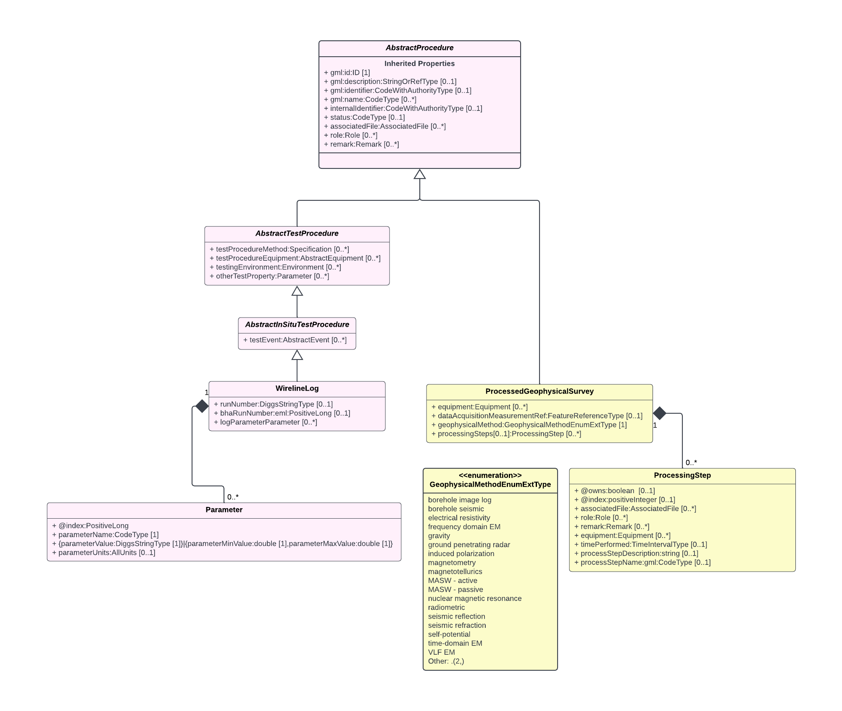

**Figure 11**. UML model of the WireLineLog and the new ProcessedGeophysicalSurvey specialized procedure objects defined to describe procedures used for direct or processed geophysical measurements. Objects in yellow are added or updated for this extension. Some pre-existing component objects have been omitted from the diagram for visual clarity.

The procedure object is named ProcessedGeophysicalSurvey. It inherits standard DIGGS feature metadata properties from AbstractFeature and adds the following 3 properties

* **equipment** – a property listing any equipment that may have been used for this procedure
* **dataAquisitionMeasurementRef** – a reference property that points to the ID of the measurement object that produced the raw data used as input into this process measurement. This property is optional and serves as a placeholder until data acquisition measurement objects are created to support the transfer of raw data.
* **geophysicalMethod** – a controlled term from an enumerated list that identifies the geophysical survey method employed
* **processingSteps** – a property that contains one or more ProcessingStep objects that describe the steps taken to produce the reported processed results, including who performed each step of the analysis, when it was performed and a link to any external files produced by the processing step or that further document the process. The example below illustrates a sample instance of ProcessedGeophysicalSurvey that might be used to describe the processing of data obtained from an aeromagnetic survey:

Example 8. Sample ProcessedGeophysicalSurvey object from a processed aeromagnetic survey

<ProcessedGeophysicalSurvey gml:id="am1">  
 <gml:name>Aeromag Survey</gml:name>  
 <role>  
 <Role>  
 <rolePerformed>Data processing</rolePerformed>  
 <businessAssociate>  
 <BusinessAssociate gml:id="cc">  
 <gml:name>Carlos Cortada</gml:name>  
 </BusinessAssociate>  
 </businessAssociate>  
 </Role>  
 </role>  
 <geophysicalMethod>magnetometry</geophysicalMethod>  
 <processingSteps>  
 <ProcessingStep>  
 <timePerformed gml:id="stp">  
 <start>2008-07-21</start>  
 </timePerformed>  
 <processStepDescription>

Upon receipt of digital data from the field, the magnetic values were checked by calculating fourth differences and preparing an error list. Single, bad magnetometer values were corrected automatically. The noise spikes were removed without making any changes in the neighboring magnetic measurements as opposed to linear smoothing or filtering routines that would mix good and bad values indiscriminately. More complex errors were corrected manually, on the basis of the fourth differences, before proceeding. (…)

</processStepDescription>   
 <processStepName>Processing of Magnetic Data</processStepName>  
 </ProcessingStep>  
 <ProcessingStep>  
 <processStepDescription>

After GSC levelling was applied to both the residual magnetic field channels (measured and gradient-enhanced), the corresponding magnetic grids were calculated from the final reprocessed profiles by a minimum curvature algorithm. The accuracy standard for gridding is that the grid values fit the profile data to within 0.001 nT for 99.99% of the profile data points, for 100 iterations (or 0.00001 nT/m for the horizontal gradient data). The average gridding error is well below 0.1 nT.  
Minimum curvature gridding provides the smoothest possible grid surface that also honors the profile line data. However, sometimes this can cause narrow linear anomalies cutting across flight lines to appear as a series of isolated spots. This effect is minimized in the gradient-enhanced residual field grids. (…)

</processStepDescription>

<processStepName>Residual Magnetic Field, First and Second Vertical Derivative Grids</processStepName>  
 </ProcessingStep>  
 </processingSteps>  
 </ProcessedGeophysicalSurvey>

Geophysical Property Dictionary Development

All DIGGS measurements utilize controlled lists of terms to identify the specific physical property being reported in the TestResult object. These terms are contained outside of the schema proper within a test property dictionary that is referenced within a DIGGS instance document. We have developed a list of draft controlled terms and their definitions to add to the existing DIGGS dictionary to accommodate reported results from the following geophysical methods:

* borehole image log
* electrical resistivity
* frequency domain EM
* gravity
* ground penetrating radar
* induced polarization
* magnetotellurics
* magnetometry
* MASW - active
* MASW - passive
* nuclear magnetic resonance
* radiometric
* seismic reflection
* seismic refraction
* self potential
* time-domain EM
* very long frequency EM
* wireline log

Physical property names for the above geophysical methods that have been compiled to date are shown in Table 2. These terms are compiled into an xml dictionary (including codes, definitions and units of measurement types and posted at: <https://diggsml.org/def/codes/DIGGS/0.1/gp_properties.xml>.



Table 2: List of geophysical measurement properties

(This is not an exhaustive list; more entries are likely with further development)

|  |  |
| --- | --- |
| **Property Name** | **Property Name** |
| absolute gravitational field strength | pore water content |
| acoustic impedance | primary compression wave velocity |
| apparent resistivity | radiation energy |
| attenuation | reflection coefficient |
| borehole wall amplitude | relative gravitational field strength |
| borehole wall image [R,G,B] | relaxation time constant |
| bouguer anomaly | resistance |
| bulk modulus | shear modulus |
| capacitance | shear slowness |
| compressional slowness | shear velocity |
| density, bulk (natural) | shear wave velocity |
| diameter of borehole | sonic porosity |
| dielectric constant | spontaneous potential |
| dielectric permittivity | temperature |
| electrical conductivity | tension |
| electrical potential | time gate voltage |
| electrical resistivity | total field strength |
| electrochemical redox potential | tube wave velocity |
| electrodiffusion potential | TWT travel time to borehole wall |
| electrokinetic potential | x component of electric field |
| electromagnetic velocity | y component of electric field |
| flow velocity | z component of electric field |
| free air anomaly | x component of in phase |
| gamma ray | y component of in phase |
| gravity gradient | x component of magnetic field strength |
| larmor frequency | y component of magnetic field strength |
| magnetic field gradient | z component of magnetic field strength |
| magnetic permeability of medium | x component of quadrature |
| magnetic susceptibility | y component of quadrature |
| mineral potential | x component of tensor impedance |
| nerst potential | y component of tensor impedance |
| number of beta particles | z component of tensor impedance |
| number of gamma particles | young's modulus |
| poisson ratio |  |

Next Steps

This initial effort to extend the DIGGS schema has focused on developing extensions for the storage and transfer of processed geophysical data that is distributed over a spatial domain. While this work should allow practitioners to transfer and access the “final” measured results from a wide variety of geophysical surveys, additional steps need to be taken to fully incorporate geophysical survey data into DIGGS more readily. These steps include:



Develop schema objects to support transfer of “raw data” acquired during data acquisition and that serve as input to the processed results

A core aspect of DIGGS’ philosophy is to not only support the standard transfer of geotechnical properties, but to also provide sufficient metadata so that the receiver of the data can know how the results were obtained so as to evaluate the efficacy of results for their intended application. As learned in our development of a conceptual model for geophysics, the “data acquisition measurements” can be complex in their structure and vary with the geophysical method.

Development of objects to support raw data transfer will require careful evaluation of each geophysical method to determine appropriate implementations. We have already begun this effort by looking at data acquisition processes for resistivity, GPR, active source seismic (including borehole seismic), and magnetics methods. It is unclear at this point how many specializations will be required to cover the full suite of methods, but we anticipate at least two structures for surface acquisition methods, one for active source and one for passive source methods, but additional structures may need to be developed.

Develop metadata objects to support transfer of external binary files

Geophysical data acquisition methods often produce a variety of data files in binary form, often in proprietary formats that can be quite large. It is neither practical nor necessary to export these data into ASCII equivalents that can transfer directly in XML. Rather, we propose to develop XML objects that will be able to reference resultant “raw data” files and describe what those files contain and how to read them. In this way, a data receiver will be provided with sufficient information to be able to access and process those files independently, if needed.

Develop appropriate compound spatial reference systems to support spatial-temporal data domains

Our current efforts to transfer processed geophysical data do not support data distributed within a spatial-temporal domain, such as seismic time-sections or time-volumes. To do so requires definition of spatial-temporal coordinate systems (where one axis is in time) We will be researching existing spatial-temporal coordinate systems and incorporate appropriate ones for use in DIGGS, and/or define new spatial-temporal reference systems.

Test geophysics schema extensions and modify if necessary

The proposed schema extensions are currently in draft form and still need to be tested in order to evaluate the utility of the schema design for real use cases. We anticipate that future schema modification will be necessary to promote adoption.

Extend and finalize physical properties dictionary

It will be necessary to add to the test property dictionary to define standardized terms for measured parameters obtained during data acquisition as well as any processed physical properties that may have been overlooked in our current effort. Dictionary additions do not involve schema changes and therefore are easy to implement. Maintaining a complete physical property dictionary under DIGGS’ auspices is important for ensuring interoperability.

Summary

The newly formed ASCE Geo-Industry Geophysics User Group has formed a task group to extend the DIGGS XML schema to enable the storage and transfer of geophysical data. This group evaluated a broad suite of geophysical methods to develop a high-level conceptual model that will simplify implementation of schema extensions, provide a roadmap for how best to proceed with schema development, and to make future extensions easier to accomplish. Following this effort, it was decided to focus first on developing schema extensions that would facilitate the transfer of the processed physical property data that derives from the raw data obtained during data acquisition. The schema extensions involve adding new objects and modifying existing objects within the sampling feature and measurement class of objects.

As the results of many geophysical methods are typically 2D or 3D datasets it was necessary to extend DIGGS’ current support for 2D sampling features and to create sampling feature objects to support the transfer of 3D datasets. Specifically, this involved:

* Modification of AbstractPlanarSamplingFeature to support multi-planar surfaces such as dogleg cross section or curved surfaces.
* Creation of a new specialized sampling feature, SurfaceSpace, that can be used for any 2D datasets that can be modeled by a single coplanar polygon, or a contiguous surface created by adjoining coplanar polygons.
* Creation of a base sampling feature object (AbstractVolumeSamplingFeature) and associated objects to represent 3D sampling spaces, and a specialized VolumeSpace sampling feature for use with processed geophysical data.

Extensions to the measurement class of objects was also necessary for efficient transfer of processed geophysical data. The existing Test measurement object was extended to allow for compact encoding of gridded data, and a new ProcessedGeophysicalSurvey procedure object was created to carry metadata about the processing steps used to convert input raw data into the processed results. Finally, we have developed a list of draft controlled terms to add to the existing DIGGS test property dictionary to accommodate reported results from eighteen geophysical methods.

The proposed schema extensions should allow for the storage and transfer of most any kind of processed geophysical data that occurs within a spatial domain. While more work is needed to support the transfer of the data collected during data acquisition as well as spatial-temporal data, we believe that this initial effort will significantly improve data exchange and interoperability among the geologic, geotechnical engineering and geophysical communities in support of geo-engineering analysis, design, planning, construction, data visualization and data archiving.

Reference

Open Geospatial Consortium, 2016, OpenGIS® Geography Markup Language (GML) Encoding Standard - with corrigendum, Document 07-036r1, <https://www.ogc.org/standards/gml>, accessed August, 2022.